GYROS offer FREE integration services to newcomers into the area and local residents.

We offer Rights Based Information, Advice & Guidance on a range of issues including but not limited to;

- Debt
- Housing
- Welfare
- Health
- Education
- Unemployment/ Searching for Employment
- Immigration Advice (OISC Level 2 accredited)

We also offer;

- Pre ESOL Classes
- ESOL- based craft club

See www.gyros.org.uk for current programmes
Opening Times

 | Shop | Walk In | ESOL | Craft Club
Wednesday  QUARTA-FEIRA  TREČIADIENIS  MIERCURI  SRODA  Среда | 10:00 – 16:00 | 13:00-15:30 |  | 10.30- 12:30
Friday  SEXTA-FEIRA  PENKTADIENIS  VINERI  PIĄTEK  Пятница | 10:00 – 16:00 | 13:00-15:30 | 10:30-12:30

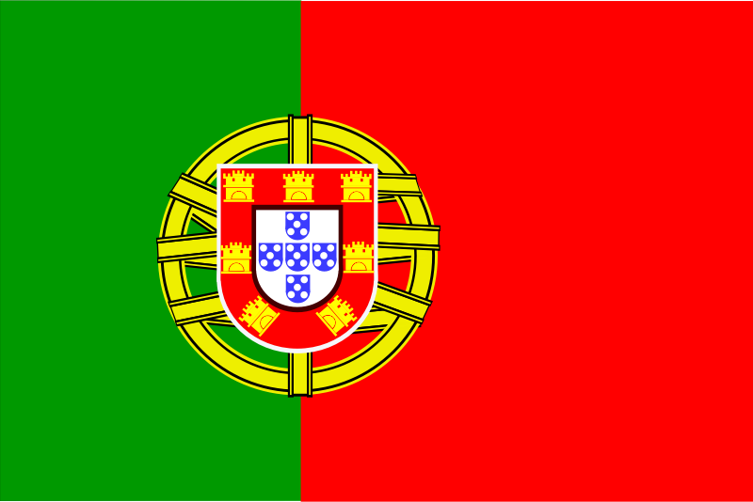 | 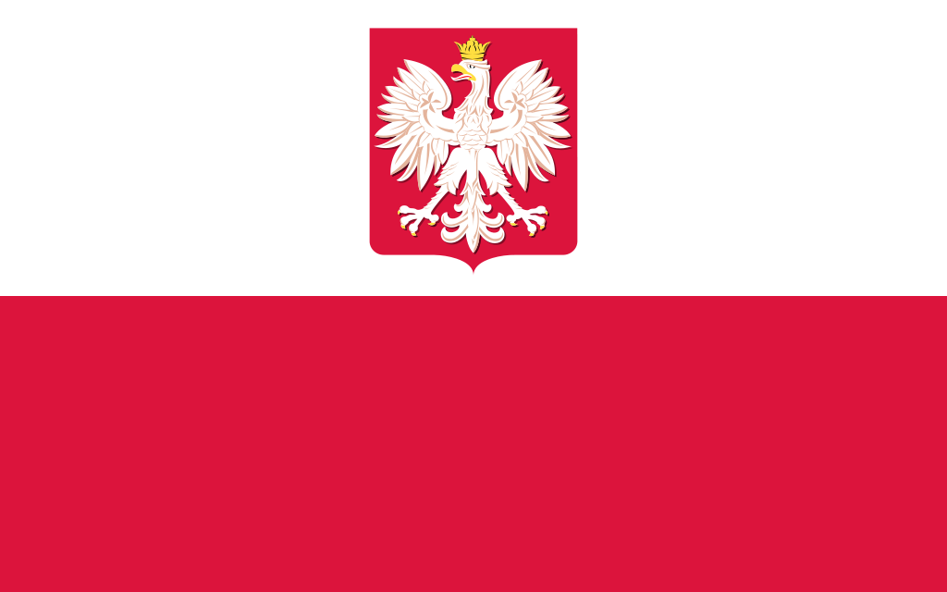 |  |  | 

GYROS offer FREE integration services to newcomers into the area and local residents.

We offer Rights Based Information, Advice & Guidance on a range of issues including but not limited to;

- Debt
- Housing
- Welfare
- Health
- Education
- Unemployment/ Searching for Employment
- Immigration Advice (OISC Level 2 accredited)

We also offer;

- Pre ESOL Classes
- ESOL- based craft club

See www.gyros.org.uk for current programmes
Opening Times

 | Shop | Walk In | ESOL | Craft Club
Wednesday  QUARTA-FEIRA  TREČIADIENIS  MIERCURI  SRODA  Среда | 10:00 – 16:00 | 13:00-15:30 |  | 10:30-12:30
Friday  SEXTA-FEIRA  PENKTADIENIS  VINERI  PIĄTEK  Пятница | 10:00 – 16:00 | 13:00-15:30 | 10:30-12:30

